**Background of Bill Joy**

William Nelson “Bill” Joy is an American computer scientist, graduate of Berkeley College and co-founder of Sun Microsystems. He is well known for his essay, “Why the Future Doesn’t Need Us” of 2000, a controversial article in which he describes his concern of the negative impacts of developing modern technology. He displays what some have referred to as “neo-Luddite” views on cybernetics, robotics and nanotechnology in particular, although he denies this himself - “I trust it is clear that I am not a Luddite”. He agrees that the Industrial Revolution helped improve the lives of people over the last couple of centuries, although he expresses dystopian views. 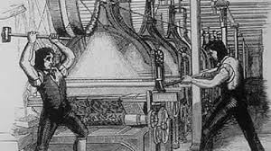

Joy writes in his article on how he was an incredibly motivated child with an eagerness to learn. He could read by the age of three, started school early and even skipped a grade later on. He later became one of the founders of Sun Microsystems, participating in the creation of technologies such as Java. Possibly his opinions have surfaced from being around technology for so long and watching it develop as quickly as it has. He writes, “Perhaps it is always hard to see the bigger impact while you are in the vortex of a change” and that the most common fault of scientists is “failing to understand the consequences of (their) inventions”. Joy also emphasises his fascination of ‘Star Trek’ throughout his youth. He expresses how the idea of ethical humans dominating the future instead of robots appealed to him greatly when he was younger.

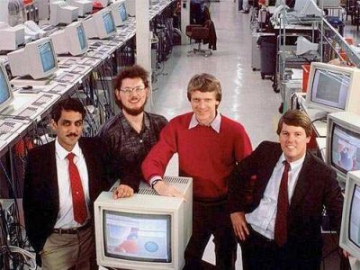

At the beginning of his essay, Joy mentions an excerpt from a book written by Theodore Kaczynski, also known as the Unabomber. Titled “The New Luddite Challenge” it had an influence on the opinions expressed throughout his article. Despite Joy looking down on the terrorist for his actions and extremely Luddite views, he sees some reasoning behind the Unabomber’s dystopian argument. He is led to discuss the question of “Just because we can do something, *should* we do it?” in relation to developing robotics and other technologies.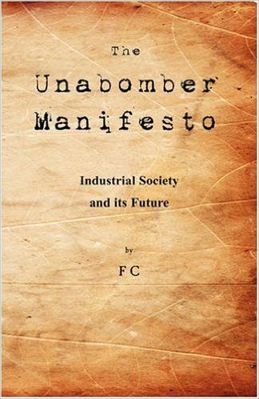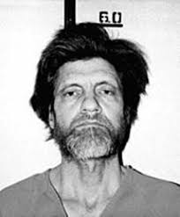

**Sources**

“Why the Future Doesn’t Need Us” - Bill Joy :

<https://www.wired.com/2000/04/joy-2/>

Bill Joy Wikipedia Page:

<https://en.wikipedia.org/wiki/Bill_Joy>

**My Contribution to the Team**

My role within our team was researching the background of Bill Joy, as well as presenting our project with our team leader. Firstly I read Joy’s article, “Why the Future Doesn’t Need Us”, which was fascinating. I also viewed his Wikipedia page to find more detailed information on his background and what shaped his opinions that he expressed throughout the article. I summarised my findings as above and stated my sources.

Since I was a presenter, I was to create a presentation on Powerpoint using each of the team member’s research summaries. I made sure that each slide was relevant to our topic and the points we were making. I also had to find suitable images for the slides and credit their sources. Along with the powerpoint, I created a script for what I was to say during the presentation with my partner. This would ensure things ran smoothly and we knew what points to talk about at each part of the presentation.